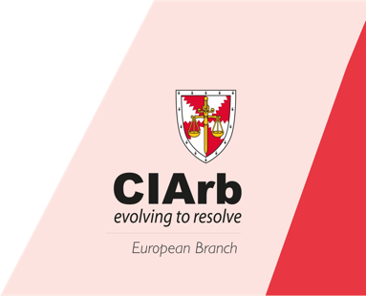
Registration Form

Module 1: Law Practice and Procedure
of International Arbitration
19.09.2020
Paris, France
Organised and managed by: CIArb European Branch
Name:

Surname:

Date of birth:

Company/organisation:

Address:

City:

Postal code:

Mobile:

Email:

Participation fee Euro € 500 shall be paid before 10 September 2020 by Bank Transfer to the following account:

Beneficiary: CIArb European Branch (Euro)
Bank: HSBC
Address: City of London Corporate Centre, 165 Fleet Street, London, EC4A 2DY
IBAN: GB85HBUK40127677299633
Swift / BIC: HBUKGB4B
(Please inform the Bank that you will pay all charges)

Once completed, please return this form to chris@chinnarbitration.com.

