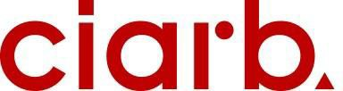

**NOTICE OF THE ANNUAL GENERAL MEETING – (Cyprus Branch)**

(Insert Date and Time)

Dear Member,

I give notice that the Annual General Meeting of the Ciarb -Cyprus Branch will be convened at 6:00pm on 12/06/2025 at the Cyprus Scientific and Technical Chamber (ETEK) Thisesos 8, Nicosia

**AGENDA**

1. Apologies for Absence
2. Minutes of the Last Annual General Meeting, (date) and Matters Arising
3. Chair’s Report
4. Treasurer’s Report and Branch Audited Accounts, year ending 2024
5. Election of Branch Committee
6. Any Other Business

Yours Sincerely,

Nicos Elia